**Record of Ex. No: 9 –Section of Solids**

**Date of experiment:** 21.06.2021 **Date of submission: 21.06**.2021

**Name:** Kunal Keshan S **Department:** ECE – A **Roll No:** RA2011004010051

**Aim:**

To learn and understand the Section of solids.

**Software used:** AutoCAD.

**Procedure:**

|  |  |
| --- | --- |
| Commands Used | Purpose of Command |
| UNITS | To set the units of the drawings. |
| LIMITS | To set the limits of the drawing area. |
| ZOOM | To adjust the view of the drawing area. |
| LINE | Used to draw a line. |
| POINT | Used to place a point on the drawing area. |
| TEXT | Used to add text in the drawing area. |
| TEXTEDIT | Used to edit any existing text. |
| DIMLINEAR | Used to add linear dimensions. |
| DIMALIGNED | Used to add aligned dimensions (i.e parallel to a line or point that is not perpendicular) |
| DIMANGLE | Used to add dimensions between any two lines or arcs. |
| DDPTYPE | Used to set the type of point and its size. |
| POLYGON | Used to draw a polygon of required number of sides, either inscribed in a circle or the circle in the polygon. Or the polygon can be drawn with respect to its edge length. |
| TRIM | Used to trim off unnecessary parts of the drawing. |
| BOX | Used to draw 3D objects. |
| SPHERE | To draw a 3D sphere. |
| CONE | To draw a 3D cone. |
| PYRAMID | To draw a 3D pyramid. |
| SECTION | Used to create the required sections of 3D objects by defining a section plane. |
| GENERATESECTION | Used to extract the 3D sectioned object as a separate entity. |
| HATCH | Used to give hatching to select enclosed areas. |

**Steps:**

1. Adjust the right units and limits of the drawing area using UNITS AND LIMITS.
2. On the bottom right, select the settings icon and select 3D Modelling.
3. Use the BOX command to draw the solid object or simply click on the box option on the top left corner in home tab.
4. For Polygons, use the POLYGON command to draw one and then use the EXTRUDE command to add height to the polygon.
5. After drawing the required solid, draw a line that acts as the sectioning plane and then select the SECTION command or SECTION from the home tab and select the line. A section will be formed.
6. Next in the same tab or by using GENERATESECTION command, select the section plane to create a separate sectioned object.
7. After adjusting the views of the objects, on the top right corner of the home tab click on views and click on the bottom right arrow to make sure that the projection is in first angle.
8. Then click on the view option again, select base and select from modal space to project the top, front and side view of the solid objects.

**Question 1:**

A Cone base 75 mm diameter and axis 80 mm long is resting on its base on H.P. It is cut by a section plane perpendicular to the V.P., inclined at 45º to the H.P. and cutting the axis at a point 35 mm from the apex. Draw the front view, sectional top view, sectional side view and true shape of the section.

Answer:

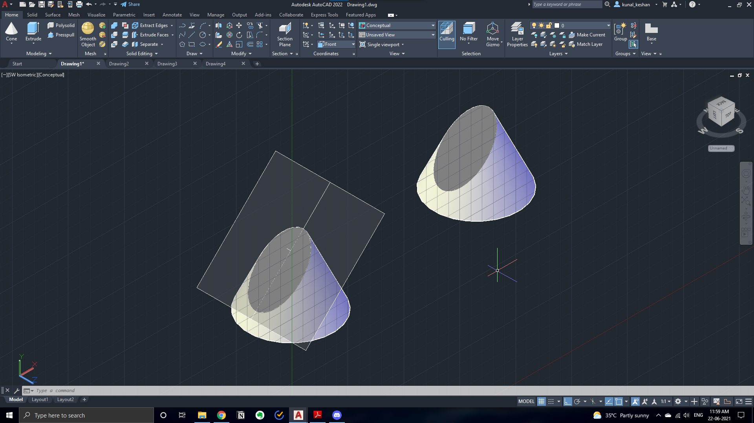

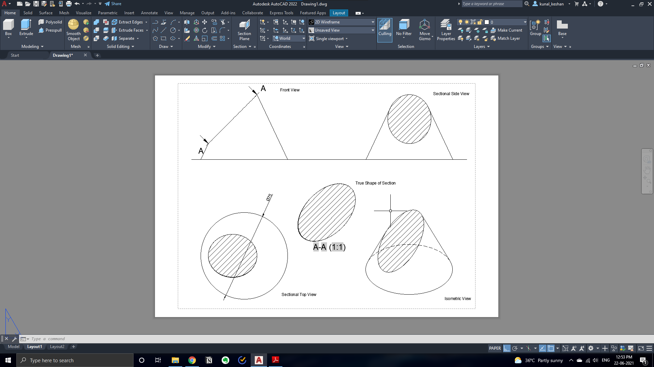

**Question 2:**

A square pyramid, base 50 mm side and axis 75 mm long, has its base on the ground and all the edges of the base equally inclined to the wall. It is cut by a section plane, perpendicular to the wall, inclined at 40o to the ground and bisecting the axis. Draw its sectional top view, sectional side view and true shape of the section.

Answer:

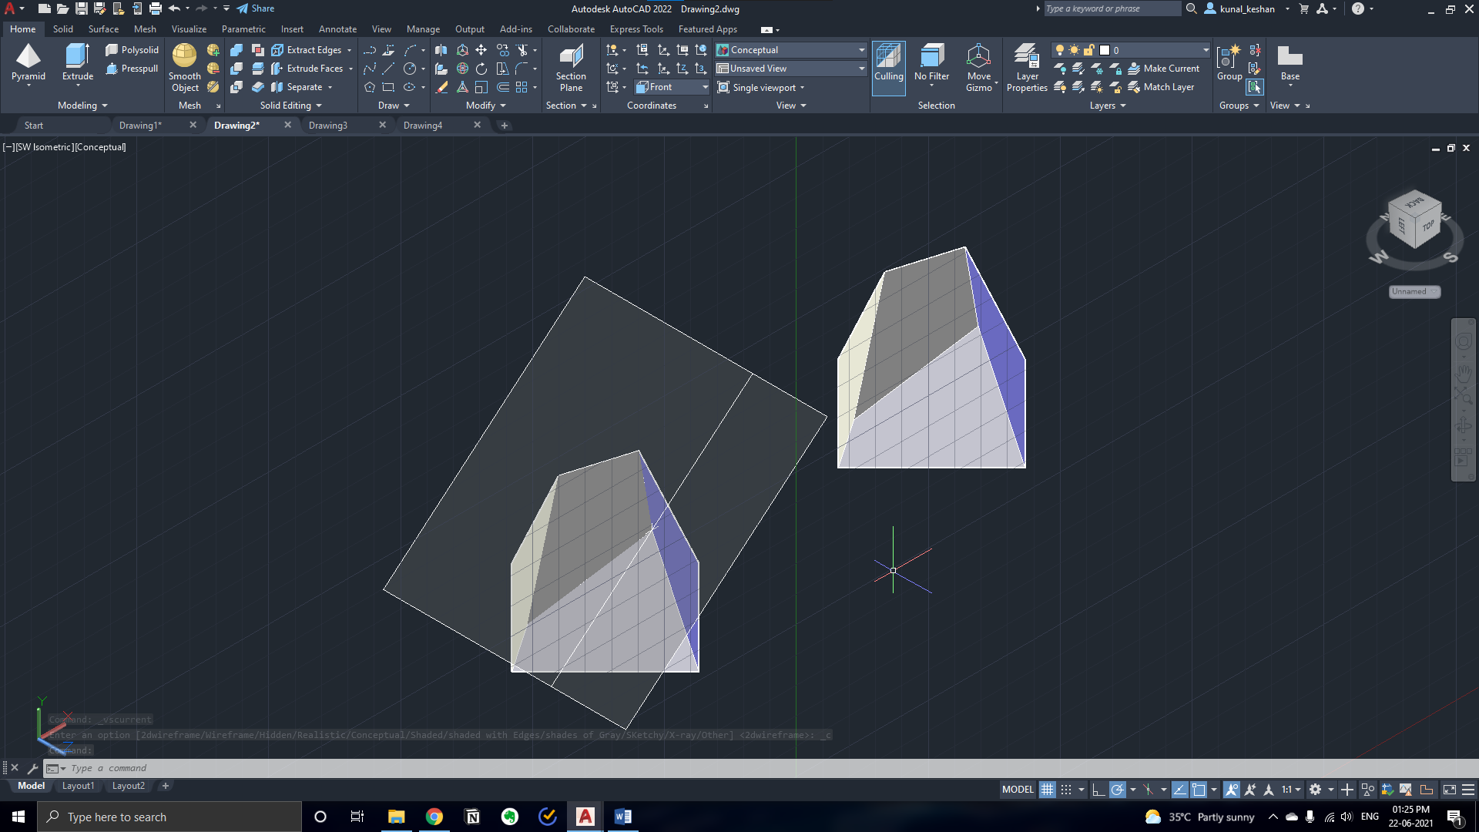

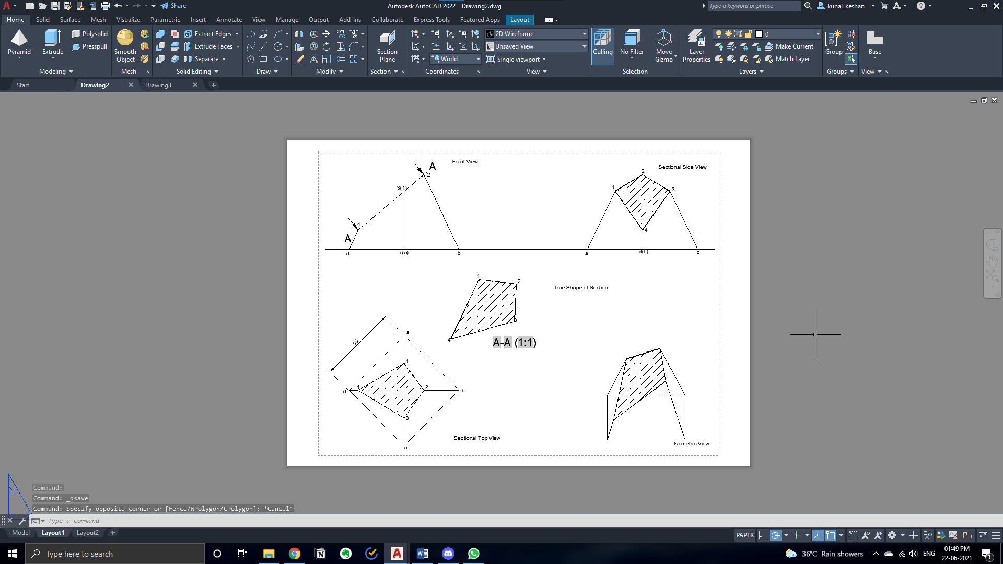

**Question 3:**

A hexagonal pyramid, base 30 mm side and axis 65 mm long is resting on its base on the ground, with two edges of the base parallel to the wall. It is cut by a section plane perpendicular to wall and inclined at 45º to the ground, intersecting the axis at a point 25 mm above the base. Draw the front view, sectional top view, sectional side view and true shape of the section.

Answer:

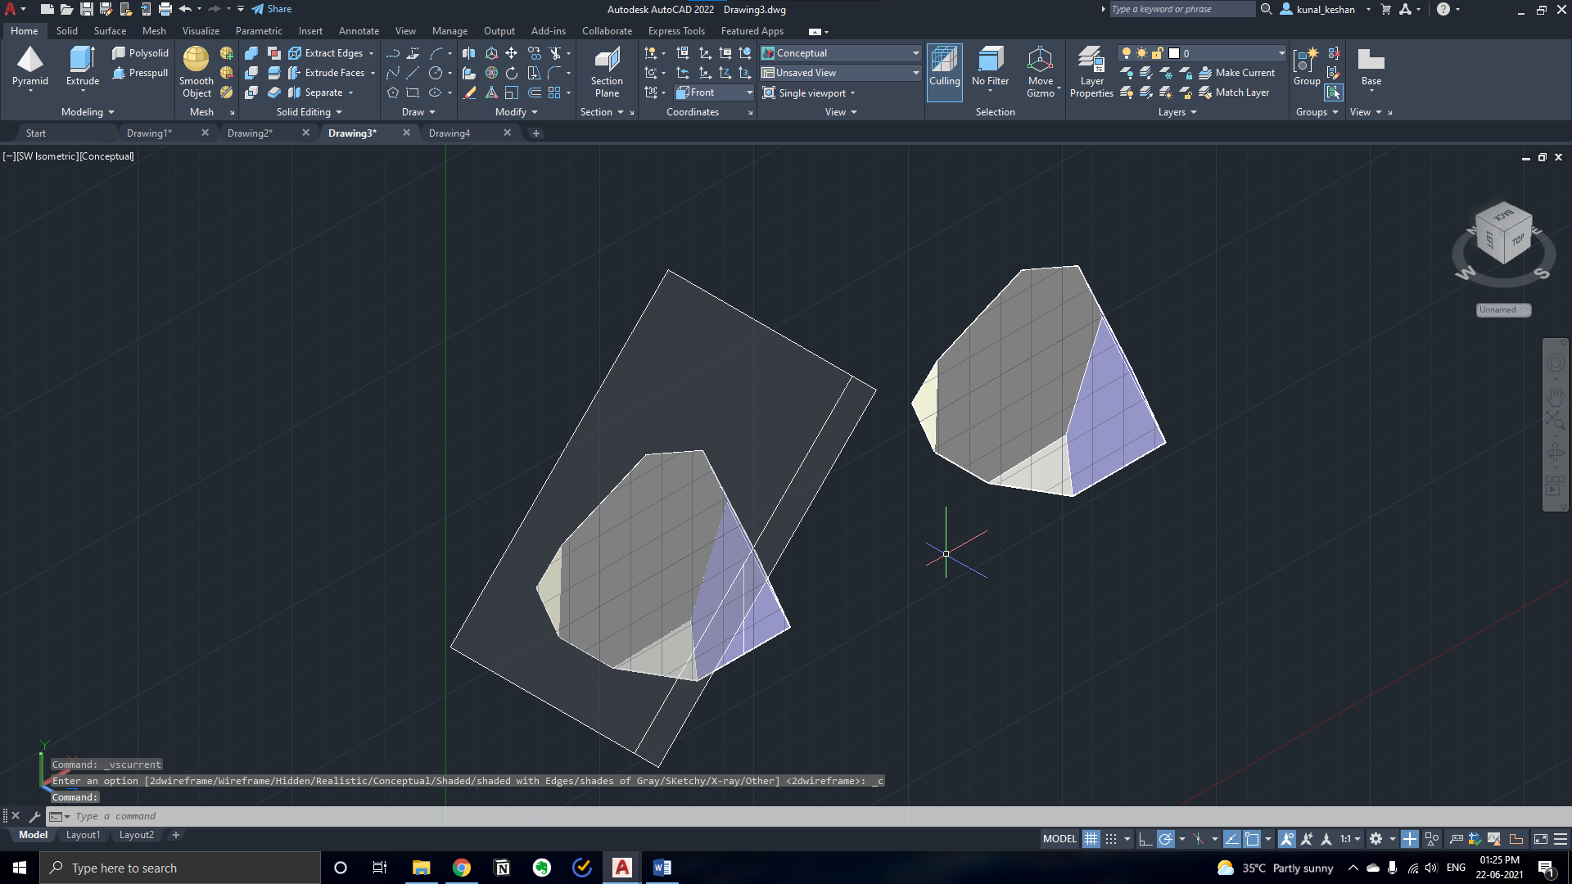

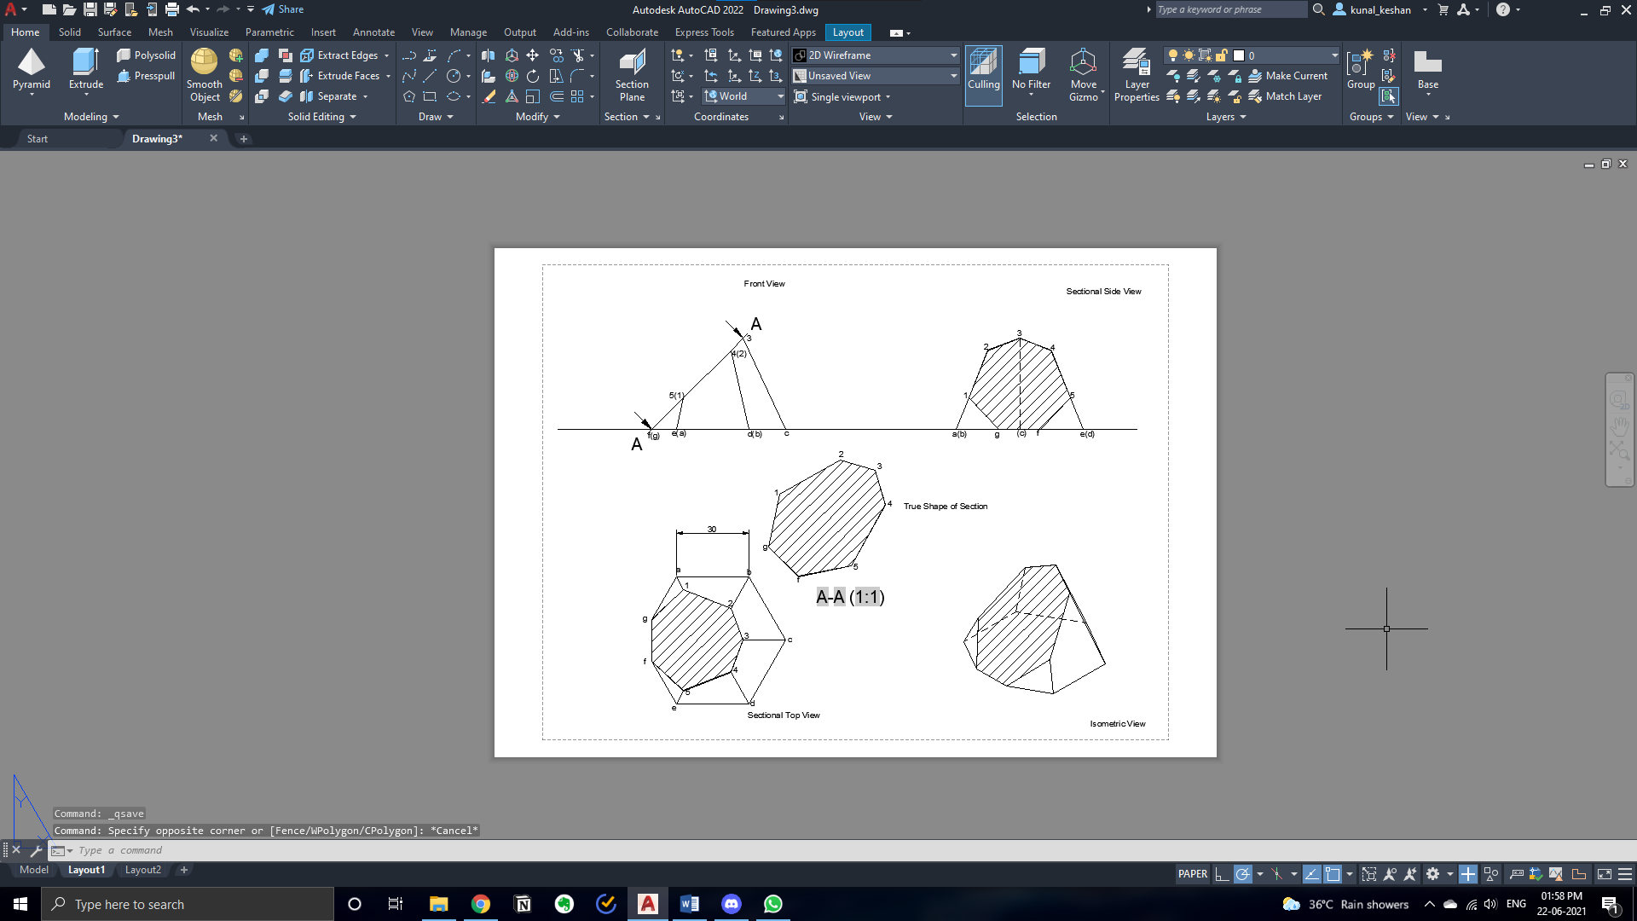

**Questions 4:**

A cylinder of 50 mm diameter, 70 mm height and having its axis vertical is cut by a section plane, perpendicular to the VP, inclined at 40o to the HP and intersecting the axis 30 mm above the base. Draw its front view, sectional top view, sectional side view and the true shape of the section.

Answer:

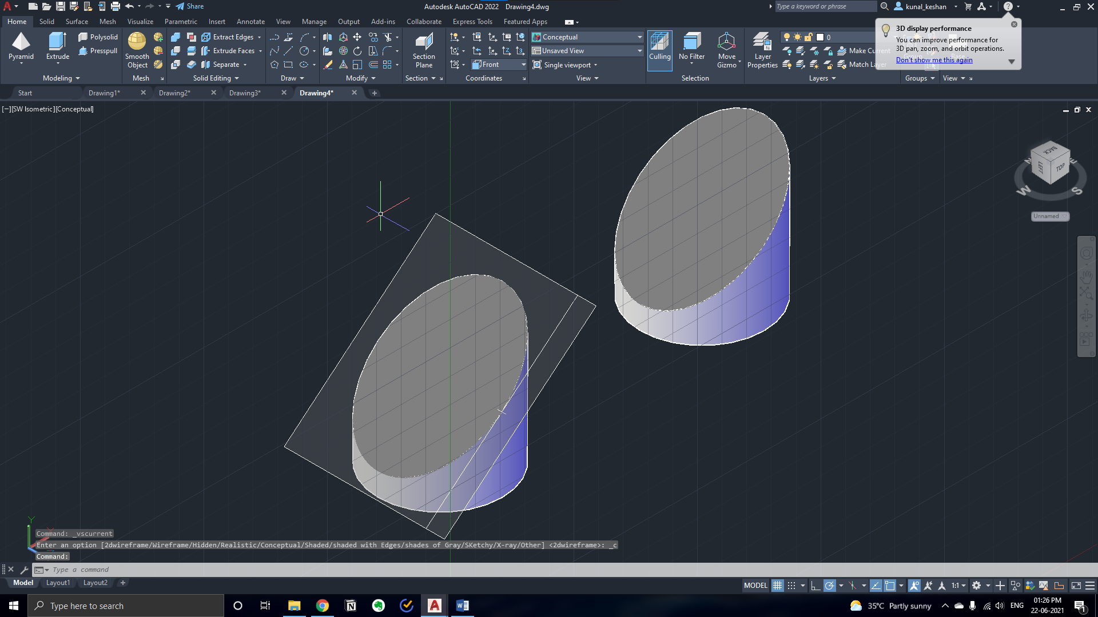

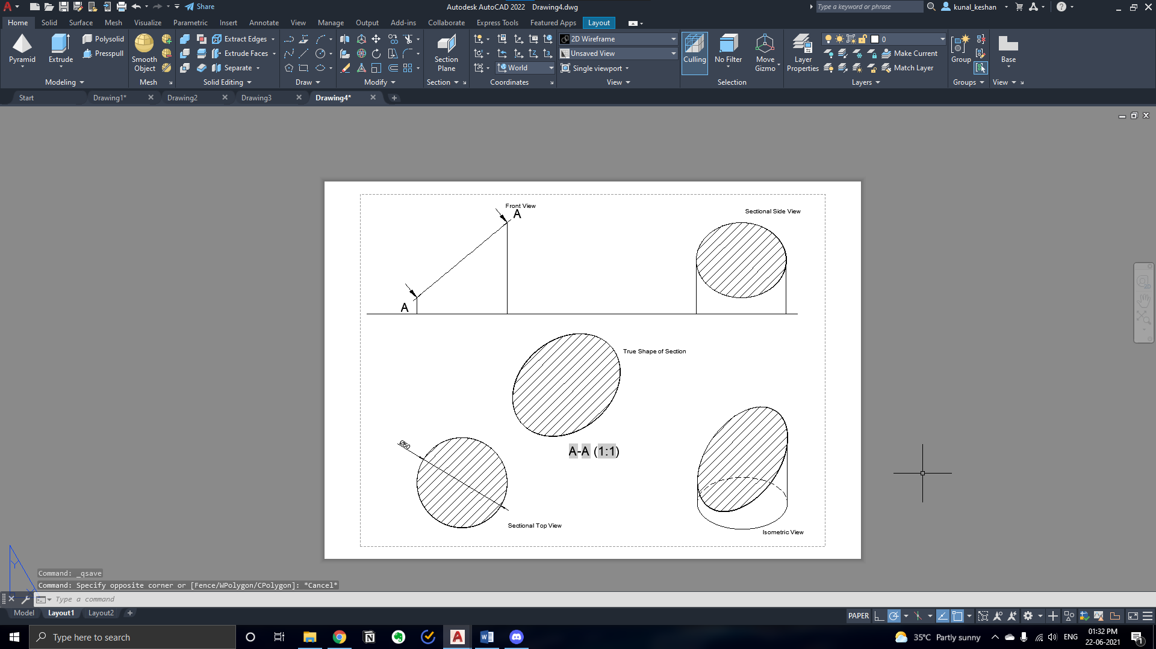

**Result:**

The given solids were sectioned according to the required dimensions.